Project Design Phase-II
Data Flow Diagram & User Stories
Date | 14 October 2026
Team ID
Project Name | Automated Network Request Management System
Maximum Marks | 4 Marks

Data Flow Diagrams:
A Data Flow Diagram (DFD) is a traditional visual representation of the information flows within a system. A neat and clear DFD can depict the right amount of the system requirement graphically. It shows how data enters and leaves the system, what changes the information, and where data is stored.
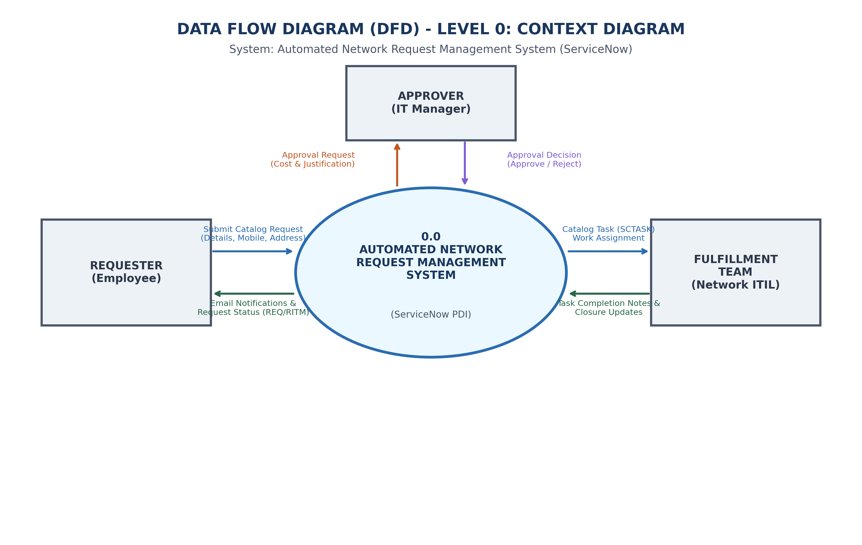
Figure 2.2: DFD Level 0 Context Diagram
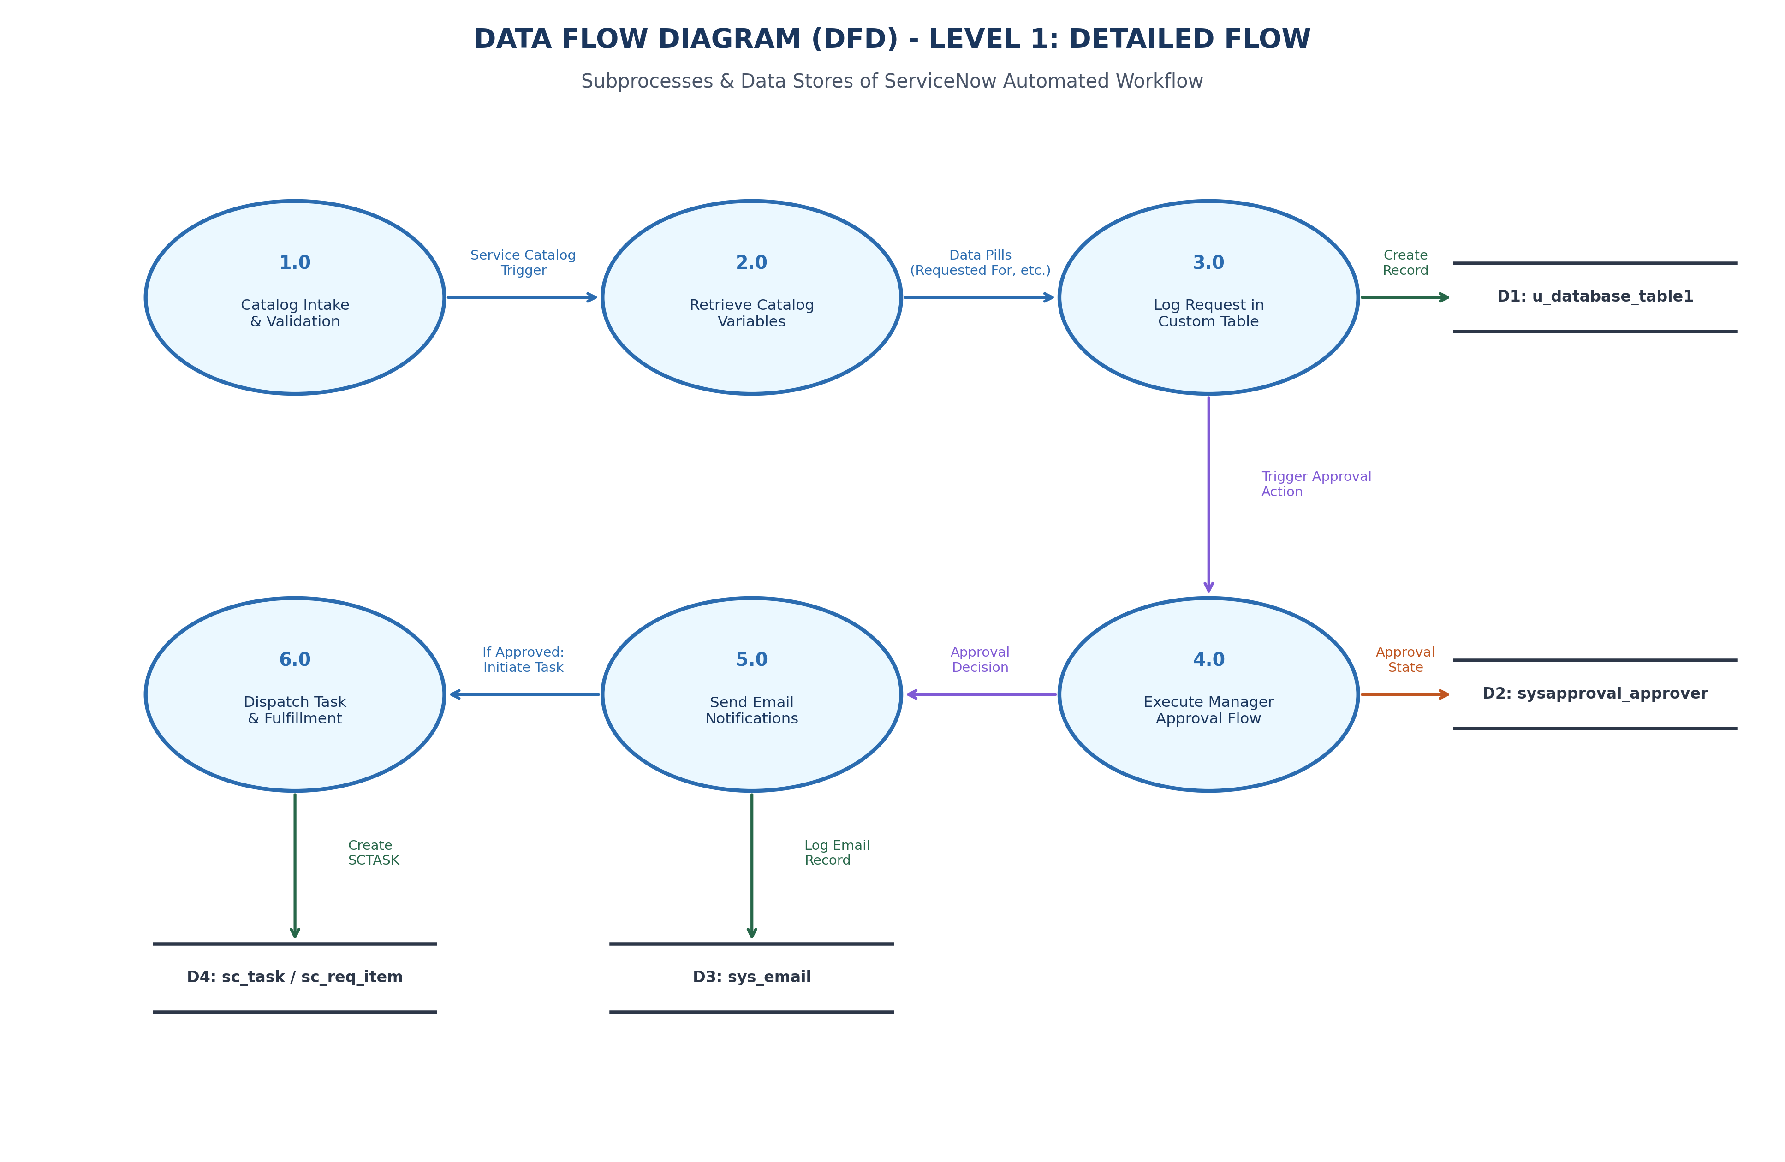
Figure 2.3: DFD Level 1 Detailed Process Decomposition
User Stories:
Use the below template to list all the user stories for the product:
User Type | Functional Requirement (Epic) | User Story Number | User Story / Task | Acceptance criteria | Priority | Release
Employee | Catalog Intake | USN-1 | As an employee, I can select 'Network Request1' from the Service Portal. | Item accessible via /sp. | High | Sprint-1
Employee | Catalog Intake | USN-2 | As an employee, I can choose Broadband, Fiber, or Wireless connection. | Choice options render cleanly. | High | Sprint-1
Employee | UI Validation | USN-3 | As an employee, 'Existing ID' shows only when 'Existing' is selected. | UI policy toggles field visibility. | Medium | Sprint-1
Administrator | Data Model | USN-4 | As an admin, request details persist in custom table u_database_table1. | Record created with mapped fields. | High | Sprint-1
Manager | Approval | USN-5 | As a manager, I receive an actionable approval record. | sysapproval_approver row created. | High | Sprint-2
Requester | Notification | USN-6 | As a requester, I receive automated email on request creation and approval. | sys_email generated with REQ details. | High | Sprint-2
Engineer | Fulfillment | USN-7 | As a network engineer, an assigned Catalog Task (sc_task) is generated. | Task appears in ITIL queue. | High | Sprint-2
Administrator | Workflow | USN-8 | As an admin, Flow Designer updates custom record status to 'Approved'. | u_database_table1 status updated. | High | Sprint-2
Administrator | Security | USN-9 | As an admin, only managers can approve requests via RBAC. | End users cannot modify approval status. | Medium | Sprint-2
Auditor | Audit Trail | USN-10 | As an auditor, complete lifecycle timestamps and logs are preserved. | Full audit history visible. | Medium | Sprint-2

